**15)**

**Aim:** To design Turing Machine using simulator over the set {a,b} to accept the input string anbn

**Diagram:**

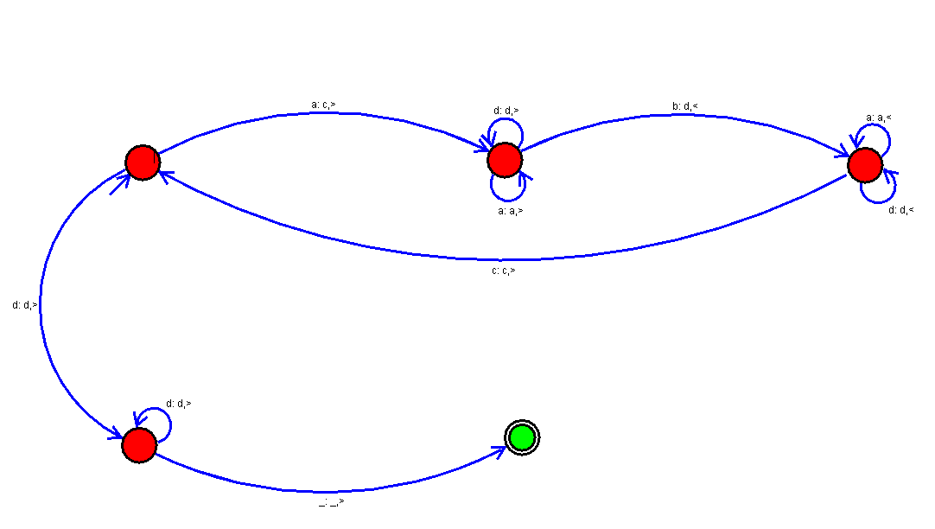

**Result:**

Thus, successfully executed Turing Machine using simulator over the set {a,b} to accept the input string anbn